Declarative Randomness for Scene Drawing in SVG
David Dailey and Eric Elder
Abstract:
Several authors have suggested that the ability to declare and define collections of random elements which vary in shape, position, size, orientation, color, and opacity could be extremely valuable for the use of SVG for scene generation. In this paper we combine our previous proposal to add <replicate> to SVG with a new proposal for declarative randomness. In combination with <replicate>, randomness adds the capacity for bounded variation of the values of attributes of repeated elements of a scene. Generating images from a high level description of similar repeated scene elements having random values simplifies an author’s goal to represent natural effects and real world settings. The use of a declarative <random> element allows authors to generate images whose characteristics are constraint-based rather than fixed. For example, scenes such as those depicting gardens, cityscapes, rain, or trees could be produced using this method. Patterns that exhibit irregular repetition, such as the markings of select animal species, can also be represented concisely using declarative repetition and randomness. Several considerations have been made to ensure that the basic conceptual model for <random> elements will be robust enough to cover many use cases. Authors can determine the distribution of random values to be uniform or normal based on their individual needs. An author can also supply a list of potential values to be randomly selected from. Resulting values of <random> elements include numbers, angles, lengths, paints, and various lists. In addition, <random> elements can be supplied a seed to initialize the pseudorandom number generator ensuring consistent results. We will be using JavaScript to implement the <random> element as a proof of concept. The implementation should demonstrate that <random> vastly extends SVG's declarative drawing capabilities. In a similar fashion to <replicate>, the values of the xml element’s attributes will be parsed and handled on the document’s load event. DOM properties of the affected SVG elements will be overwritten with the calculated result of the <random> element. Randomness can be useful when introducing noise into a graphical model is desirable. This could be particularly useful for modeling communication networks. InkML trace groups can be represented with high quality in SVG using <replicate> and randomization. Included will be an analysis of the use cases of InkML: applying <replicate> with <random> to introduce randomness into trace groups to make handwriting or other typography appear more natural.

“Innovation is serendipity, so you don't know what people will make”
-- Tim Berners-Lee [1]
Introduction
Randomness is funny stuff. To begin with, we don’t really know if it exists, though, often, depending on our mood, it seems to.
Words whose definitions depend on one another can be seen as semantically associated. Closely associated with the term “randomness” are allied notions of surprise, deviance, unpredictability, chaos, normalcy, pattern, and periodicity. Using methods of semantic proximity by bootstrapping from Roget’s Thesaurus (a process described in [2]), the “best “ 15 synonyms for “random” are in order
shapeless incoherent amorphous inchoate disordered vague casual haphazard unorganized formless indiscriminate promiscuous irregular desultory capricious
Ultimately, that which is truly random, is that which appears outside of theory or reason. Randomness (if it exists), in some sense, can be seen as a fundamental force that is in perpetual conflict with order, almost as though the two work together to form and regulate our universe as well as to allow to change.
Its status in philosophy, science and art, has been a long-time source of speculation and controversy.
In early Greek cosmology Chaos was seen as the primal soup from which the Universe was later formed. In later European philosophy (as well as in historical theories of Western art) the interrelated roles of determinism, mechanism, science, teleology, free will and God’s will all helped to frame continental disputes between such as viewpoints as advanced by Idealists, Positivists, Determinists, Materialists and Spiritualists. Generally, through these disputes, randomness or indeterminacy was viewed as either the absence of understanding, the expression of God’s will, or the expression of free will.
Within classical (pre-Impressionist) theories of art, the role of randomness (or even its less sinister-sounding avatar: serendipity) seems largely to have been avoided, with most major art theoretic discussions over the centuries focusing, rather, on the importance of inspiration vs depiction. Some art, could reach purity because the artist’s ego, in a sense dissolved, with the artist becoming merely a vehicle for the expression of the essence of the object. On the other hand, the spark of imagination, perception, truth or divine inspiration within the artist might bestow into art a beauty that is external to the object being portrayed. Those were the big questions of art theory: how much of art is the person; how much is the object being portrayed; how much comes from Elsewhere (where Elsewhere was generally viewed as a form of spirit). Clearly, one’s philosophical leanings on issues of free will and determinism would help to shape her perspective in such debates.
In the 15th century in the first modern treatise on the theory of painting [3] Alberti writes
I say the function of the painter is this : to describe with lines and to tint with colour on whatever panel or wall is given him similar observed planes of any body so that at a certain distance and in a certain position from the centre they appear in relief, seem to have mass and to be lifelike.
This focus on the object being portrayed is contrasted with the much earlier Idealism of Plato. Panovsky, 1924 [4] writes:
Plato determined the value of a work of art in the same way as he did that of a scientific investigation – by measuring the amount of theoretical and especially mathematical insight invested in it.
He continues:
In fact, a systematic separation of aesthetics from the theoretical and ethical spheres was not attained before the eighteenth century.
Rensselaer Lee [5] observes
But toward the end of the sixteenth century, the painter-theorists like Lomazzo and Armenini were no longer concerned, as Leonardo had been, with recording new technical or scientific knowledge based on actual experiments with painting. Instead they were interested in organizing and codifying knowledge already at hand.
Panofsky points out that “whereas Seneca [1st century] said that God is ‘inwardly full of figures’ Durer [16th century] said the same thing of man.”
Though Durer’s allusion to the plenitude of material residing within the artist, could suggest that a spark of serendipity might also reside, the first embrace of randomness as a part of creative expression seems to have arisen within Dada, where it was seen as overt defiance of the established order of classicism and Neo-classicism.
The noted art historian H.W. Janson notes [6]
Yet Dada was not a completely negative movement. In its calculated irrationality there was also liberation, a voyage into unknown provinces of the creative mind. The only law respected by the Dadaists was that of chance, and the only reality, that of their own imaginations.
With time and the advent of Surrealism and Pop, the revulsion against randomness in art may have begun to subside somewhat, though it has retained a bit of its subversive undertone:

Chance has been understood as both a liberating source of unforeseen possibilities
and a threatening force capable of undermining human self-sufficiency and
moral self-determination. As an indication of the world’s instability and our uncertain
position within it, chance has been a perennial concern in the visual arts as subject
matter and theme. [7]

The notion that randomness might have value in art has perhaps gained traction as a function of time and advances in the sciences:

Information theory equates randomness with unpredictability and, at odds with other definitions, concludes that a higher level of randomness indicates a greater concentration of information; a message’s probable denseness of information is highest when the message is partially surprising and partially expected. There is no fixed definition for what randomness means in art, but analogies can be drawn to how the term is used in other fields. For example, information theory’s definition might suggest that artworks have the greatest impact when using a mixture of pattern and unpredictability.[8]

Two other things within science and mathematics may have helped: the rising popularity of both Monte Carlo analysis and fractals.

Monte Carlo techniques [9] were developed shortly after the Manhattan Project at Los Alamos. They turned the traditional use of random numbers a bit upside down: instead of using random numbers to help estimate uncertainty, they were now being used to solve mathematical problems that were beyond the reach of traditional mathematics. That is, in a system with many interdependencies or covarying degrees of freedom, it may be simpler to build and activate a random process and observe its behavior within that system than to solve the various differential equations that might arise from an equivalent formulation of the system.

Stanislav Ulam recounts:

The first thoughts and attempts I made to practice [the Monte Carlo Method] were suggested by a question which occurred to me in 1946 as I was convalescing from an illness and playing solitaires. The question was what are the chances that a Canfield solitaire laid out with 52 cards will come out successfully? After spending a lot of time trying to estimate them by pure combinatorial calculations, I wondered whether a more practical method than "abstract thinking" might not be to lay it out say one hundred times and simply observe and count the number of successful plays. This was already possible to envisage with the beginning of the new era of fast computers, and I immediately thought of problems of neutron diffusion and other questions of mathematical physics, and more generally how to change processes described by certain differential equations into an equivalent form interpretable as a succession of random operations. Later [in 1946], I described the idea to John von Neumann, and we began to plan actual calculations. [10]

Since that time, the use of Monte Carlo methods in simulations in the natural sciences, the social sciences, economics and even the humanities has become a commonplace tool in the academic and applied arsenal for understanding complex processes.

That randomness could be useful in predicting physical phenomena rather laid moot the well-known philosophical disputes between Einstein and Bohrs over the true nature of the Universe: is it deterministic or not? Do sub-atomic particles really have uncertainty? Is randomness real? To a large extent, Monte Carlo analysis showed that from at least one practical perspective, it doesn’t really matter.

Ulam’s later work on cell-growth problems [11] helped set the stage for such simulations as Conway’s well-known “game of life” and the sort of thinking that results from contemplating the interrelationship between rules and pseudo-randomness no doubt had considerable influence on the emergence of Chaos theory and Benoit Mandelbrot’s very popular theory of fractals [12].

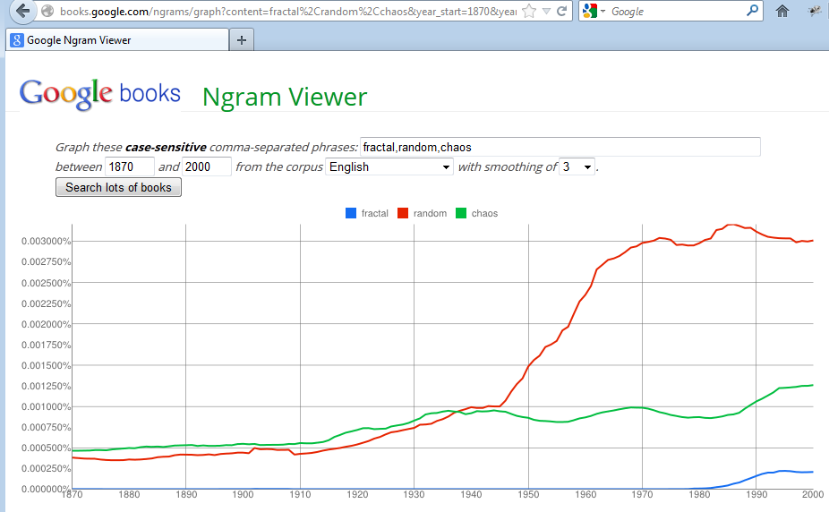
Figure 1: Google Ngram chart of lexical frequencies (in books) for “random” (red), “chaos” (green), and “fractal” (blue), over the years 1870 – 2000.
“Fractal patterns with various degrees of self-similarity have been rendered or studied in images, structures and sounds and found in nature, technology, and art.” [Wikipedia, 13]
An argument can and has been made that the quasi-randomness of fractals is already found in 20th century expressionist art [14]. Fractals were greeted with considerable enthusiasm by the computational arts community because of their promise for the automatic generation of realistic scenery. Unfortunately, the mathematical sophistication needed to control fractals, as defined by Mandelbrot, as well as the computational intensity of their construction have both served to dampen a bit of that enthusiasm. However, the allied approaches of Perlin noise and Simplex noise [15] have given rise to a greater application of the basic concepts in applications.
Within SVG, there are two sources of randomness: JavaScript (which contains a function Math.random() that returns floating point numbers between 0 and 1) and feTurbulence.
The clever massage of Math.random() to produce integers, words, or colors is not beyond the understanding of a second semester programming student. However, using script to produce random narratives, poems, scenes, movies or even simple polygons, is a considerably more complex endeavor requiring far greater sophistication in programming, mathematics and computational graphics. The drawing of random polygons, for example, was widely believed to be computationally intractable for large numbers of vertices, prior to very recent work (2008) [16]. That is, the techniques of bringing randomness into SVG are not so widely accessible as might be demanded of a declarative language for graphics.
The use of feTurbulence to inject realism into scenes in SVG has been covered fairly extensively [17]. The problem reported by many practitioners (including students of mine who have been professional programmers with extensive knowledge of graphical systems), is that to make it “useful” turbulence must be chained with other filter effects such as feComponentTransfer, feGaussianBlur, feDisplacmentMap, feColorMatrix, feMergeNode and feComposite . Learning how to create a desired effect from these filters, requires extensive familiarity and practice with the filter primitives. Not many people seem to have found time to allocate to such a steep learning curve. It is undoubtedly because of these perceived difficulties in the use of filters, that the CSS working group, enamored of the glitz and appeal of SVG, but stricken a bit by its complexity, have proposed a few “canned” effects. These consist of “A small set of canned filter functions that are given by name. While not particularly powerful, these are convenient and easily understood and provide a simple approach to achieving common effects, such as blurring.” [18]
I think that all who are familiar with the use of feTurbulence to bring in a source of quasi-randomness into our scenes would concur that it is not for the faint-hearted.
As one who learned to appreciate SVG very early in the 21st century, I can say that what appealed to me about it was the parsimony of the code, the elegance of expression, and the power of those expressions. Things like <use> and <g> and modifiers like <clipPath>, <filter>, <gradient>, <pattern>, <mask>, <glyph> and <animate> as well as the ability to nest arbitrarily complex SVG content within at least some of those modifiers was most pleasant from an architectural sense. Its power/effort ratio was very high. The language had beauty. It was in this spirit of appreciation for the language’s architecture and expressiveness, that <replicate> proposal [19, 20] came to be.
Now after four years of enjoying the opportunity to think about the <replicate> proposal and how convenient it is to multiply, extrude, interpolate, extrapolate, shape and sculpt using purely declarative techniques, the authors have had time also to speculate on why the corporations and people who oversee the standards of the web, have not be so quick to embrace <replicate> as those who actually have used it. Perhaps, we decided, it was because they had seen had not come to appreciate the sheer size of the power/effort ratio. So, we decided, it was time to expand that ratio a bit more.
Oftentimes, in creating a scene, one wishes to replicate things that vary a bit (in color, shape or size) and then to drop them into the scene at relatively random locations. Hence, we reasoned, the need for declarative randomness in SVG! Yes, we know that script and filters can already give some randomness to SVG, but as argued above, neither is easy to use, and both lower our power/effort ratio to a level that few SVG authors seem to have undertaken the effort.
The initial proposals for declarative randomness [21,22,23] were made with the thought that randomness might be added into SVG through the addition of universal attributes that could be sprinkled into tags here and there. After considerable thought and discussion, Eric made the argument that it would be both more extensible (to cases other than just <replicate>, like <animate>) if the randomness module were introduced, instead through a <random> tag. That is the syntax that we have pursued and what follows are our experiments with that some of the use cases that we and others have identified in our discussions to date [25, 26, 27, 28, 29, 30, 31].
Basically, what we wanted was the ability to randomize the values of attributes for almost all SVG elements. That would allow us to randomize colors, shapes, positions as well as textures, opacities, aspects of the interactions of objects through filters and so forth. The sorts of scenes we had in mind involved many of the things like clouds, fire, grass, and pebbles that tend to define earthly scenes. Clearly, though, realistic portrayals are not the only source of expression that might be augmented through declarative randomness.
Using <random> and <replicate>
The use of <replicate> is rather extensively detailed in our proposal [20]. Numerous examples are illustrated in our compendium of examples [32].
The current production code for <replicate> with <random> can be used by including the following <script> tag (to simulate what SVG would be like if these were a part of the spec):
<script xlink:href="http://cs.sru.edu/~svg/rep.js" />
As the <replicate> project is also part of an open source initiative, the community project site is located at http://code.google.com/p/svg-replicate/ .
We have allowed the user to either specify namespaces (a good practice in working in multiple namespace environments) or not (perhaps better for teaching concepts, a context in which clutter that is extraneous to the cognitive task at hand harms the learning process).
By using the opening tag:
<svg xmlns="http://www.w3.org/2000/svg" xmlns:xlink="http://www.w3.org/1999/xlink" xmlns:svgr="http://granite.sru.edu/svgr">
one may either, with namespaces, use code that looks like:
<circle cx="10" cy="300" r="1" >
<svgr:random attributeName="cx" min="0" max="300" />
<svgr:replicate repeatCount="1000" />
</circle>
or without namespace declarations like:
<circle cx="10" cy="300" r="1" >
<random attributeName="cx" min="0" max="300" />
<replicate repeatCount="1000" />
</circle>
One of our authors is strongly interested in standards compliance and best practices. The other has spent too many years trying to educate the youth of the world to abandon the belief that simpler is better, and tends to believe that standards should follow people rather than the other way around. You will be able to tell from the examples below, which author has had the final revision. We also like to think that <replicate> and <random> will eventually be a part of some version of SVG (or a future declarative graphical standard), so it is nice to see the latter example, just to help prove the case of how simple it will all be, when the browser implementers are finally convinced, through logic, beer or corporate takeover.
Types of randomness
We are interested in allowing some control over the nature of the distribution. Currently, we allow two modes: uniform and simulated normal. The normal distribution is formed by simply relying on the central limit theorem and summing the results of 12 random uniform numbers and then dividing by the variance in which in the case of a uniform distribution is 1/12 the class interval. Accordingly, we will get a reasonable approximation. The Box-Muller transform [34] is another common approach, and though we initially avoided it because of the reliance on trigonometric functions (fearing the performance hit) we are considering using it as a part of the technique. We are also considering other sorts of distributions, and will hope for some input from the Web Graphics community into the sorts of distributions that might be relevant to visual scene generation.
We will show examples momentarily, but for now, the syntax for controlling distribution looks as follows for the uniform (default) and normal distributions:
<random attributeName="cx" min="0" max="200" />
<random attributeName="cx" min="0" max="200" distribution="normal" />
We use the same parameters min and max to help specify the variability of the random variable, though, in the case of the distribution “normal” it is only an approximation to the “range” since a normal distribution has infinite range.
Early in our public discussion of use cases [25, 26, 27, 28, 29, 30, 31], it became clear that a desired criterion of randomness was the ability to repeat a given effect by controlling the effects of randomness with a seed. This clearly meant rolling our own random number generator, since JavaScript’s Math.random() does not accept a seed. After a bit of investigation into alternative methods, we settled on [33 Eric – describe this and provide a reference]
Hence, we allow two possibilities: the default, using no seed which gives different values at each invocation, and with a seed that allows the user to specify a numeric value for the seed so as to produce equivalent effects from one load of the page to the next.
The syntax of these two techniques would be (for the simple case of randomizing the center of a circle), the unseeded (default):
<random attributeName="cx" min="0" max="200" />
and, the seeded variety:
<random attributeName="cx" min="0" max="200" seed="11003" />
What may not be apparent at first glance, is how to use this in combination with <replicate> since a seeded value will return the same value for each instance of the replicated object. Clearly, in the common use case of wanting to replicate while making random variations, we do not want all the values of the attribute to be the same, but only the “first” instance on loading of the page. This is handled through a previous feature of the <replicate> syntax: the <replicateModifier> element, and we will discuss examples soon.
In the meantime, we will begin with some simple examples to give the reader a concept of how replicated randomness actually works.
Simple examples: varying placement, size, color.
Placement: Let us examine, first, a sort of simplest case: simply replicating the x position of the center of a circle, making 100 replicates that occur at equal intervals from left to right.
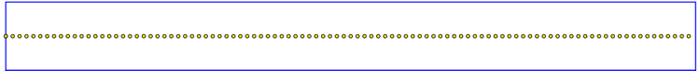
<circle cy="11" r=".5" stroke="black" stroke-width=".2" fill="yellow" >
<replicate repeatCount="100">
<replicateAttribute attributeName="cx" from="0" to="200" />
</replicate>
</circle>
Replicating at equal intervals from left to right.

This example and the two following ones can be seen at http://cs.sru.edu/~ddailey/svg/Horizontal3.svg
Now, instead of spreading the circles across equal intervals, we will distribute them randomly, but uniformly:
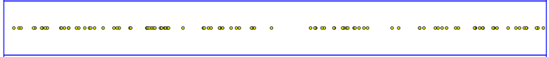
<circle cy="31" r=".5" stroke="black" stroke-width=".2" fill="yellow" >
<random attributeName="cx" min="0" max="200" />
<replicate repeatCount="100" />
</circle>
Uniformly distributed over the interval 0 to 200.

A simple addition of the distribution attribute is enough to change the random distribution from uniform to normal:

<circle cy="51" r=".5" stroke="black" stroke-width=".2" fill="yellow" >
<random attributeName="cx" min="0" max="200" distribution="normal"/>
<replicate repeatCount="100" />
</circle>
Normally distributed

One other similar situation arises that is illustrated as the fourth example at http://cs.sru.edu/~ddailey/svg/Horizontal3.svg. It distributes the circles randomly within bounded intervals that are themselves laid out equidistantly. This is a bit different from the ability to lay the circles out horizontally from left to right, but with random intervals between them. It is a use case that we do not have a good declarative solution for yet. That is, we may product a random monotonically increasing function on cx, but not one which takes into account the value previously generated.
Size: While replicating a series of circles from left to right across the screen, let us vary their sizes randomly. In the next example (Color), size is varied among members of a discrete list.
<circle cy="11" r=".5" stroke="black" stroke-width=".2" fill="yellow" >
<random attributeName="r" min="1" max="3" />
<replicate repeatCount="100">
<replicateAttribute attributeName="cx" from="0" to="200" />
</replicate>
</circle>
Varying the size of circles as they are replicated from left to right

This example is visible at http://cs.sru.edu/~ddailey/svg/Size.svg .
Color: In the example visible at http://cs.sru.edu/~ddailey/svg/B0a.svg a series of dots are laid down across the screen using <replicate>: 15 dots across and 10 dots down. Note that since cx is being varied already for the ellipses to replicated them horizontally, we use nested replications on each group of 15 to replicate that group 10 times, with the translate command being varied to produce the vertical replication. Each ellipse is assigned a random color (in the RGB color space) with colors varying anywhere between 30 and 160 on the Red channel and 45 and 85 on the Green channel with the Blue channel kept constant at 40. For many of our experiments, we have chosen to use the HSL color space since it gives better control over saturation and brightness values.
Another important and interesting feature of this example, is that we’ve chosen exactly two discrete values for the value of rx – either 12 or 26. This ability to choose either discrete values or values within a continuous interval can prove very handy.
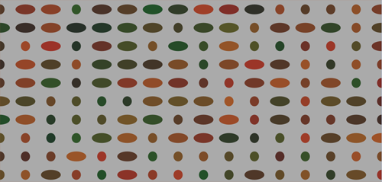
<g transform="translate(0,1000)">
<replicate repeatCount="10" >
<replicateAttribute attributeName="transform"
values="translate(0,0);translate(0,1000)" />
</replicate>
<ellipse cx="1000" cy="55" rx="20" ry="27">
<replicate repeatCount="15" >
<replicateAttribute attributeName="cx" values="0;1000" />
</replicate>
<random attributeName="fill"
min="rgb(30, 45, 40)" max="rgb(160, 85, 40)" />
<random attributeName="rx" values="12;26" />
</ellipse>
</g>
Replicated dots in a grid, with random colors.

A very similar example at http://cs.sru.edu/~ddailey/svg/randomB0.svg lays out the grid more symmetrically, with the following code replicating two nested groups: one horizontally and the other vertically:
<g transform="translate(0,1000)">
<svgr:replicate repeatCount="20" >
<svgr:replicateAttribute attributeName="transform" values="translate(0,0);translate(0,1000)" />
</svgr:replicate>
<g transform="translate(1000,0)"><svgr:replicate repeatCount="30" >
<svgr:replicateAttribute attributeName="transform" values="translate(0,0);translate(1000,0)" />
</svgr:replicate>
<ellipse cx="20" cy="20" rx="10" ry="15">
<svgr:random attributeName="fill" min="hsl(0, 55%, 10%)" max="hsl(50, 80%, 30%)" />
</ellipse>
</g>
</g>
Replicating randomized shapes
In the example at http://cs.sru.edu/~ddailey/svg/rnd-trial4a.svg are shown two steps in the creation of a fire-like effect. (Note: in our talk at SVG Open last year on text effects, we used feTurbulence to create some more perhaps more convincing and animated fire effects [35])
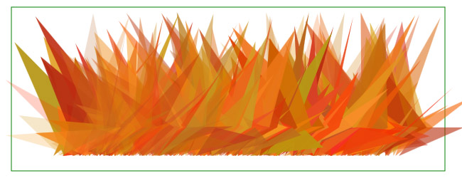
<path fill = "none" stroke = "black" stroke-width = "0" opacity = "1" >
<svgr:random min="M 146 204 200 164 80 0 z"
attributeName="d" max="M 200 204 250 164 300 200 z" />
<svgr:random attributeName="fill" min="rgb(180,40,0)" max="rgb(255,160,40)" />
<svgr:replicate repeatCount="400" >
<svgr:replicateAttribute attributeName="transform"
values="translate(-300, 0);translate(150,0);translate(-300, 0)" />
<svgr:replicateAttribute attributeName="opacity" values="1;.2;1;.2" />
</svgr:replicate>
</path>
Replicating randomized triangles, by varying the d attribute.
.
In this case, we replicated 400 triangles first from left to right and then back again, so that there would not be a “directional” effect with triangles to the right laying atop those to the left. Two of the triangle’s points have their y axis clamped while the third (which also varies more wildly in the x direction than the other two points) is free to vary. In the example on the web, one can see the value of looping back leftward after one traversal to the right. Opacity is set to oscillate twice per horizontal sweep.
Later in the paper, we will talk a bit about the difficulties associated with animating certain scenes like the above, so that objects have their own animations, but nonetheless stay relatively true to their own unique forms. It is something that might require changes of some aspects of SVG itself.
Other examples have been used to play with randomized shapes, including a good many of the examples at http://cs.sru.edu/~ddailey/svg/replicateRandom.html . We will consider a couple more of these for their pedagogical value.
The basic form of the random medieval town at http://cs.sru.edu/~ddailey/svg/rnd-trial5.svg is relatively simple: pentagons that have been fixed along the base, with only the apex of the roofs varying.
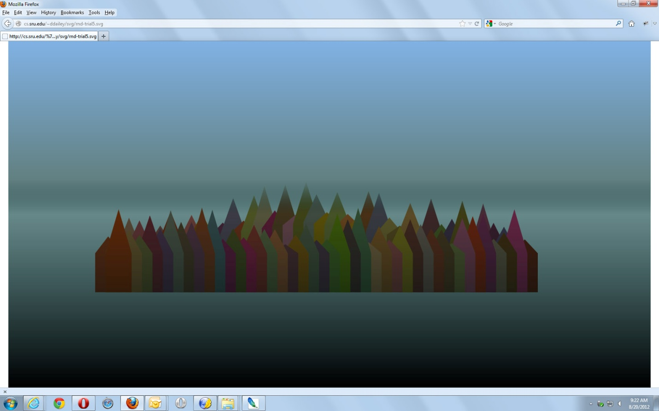
<path fill = "none" stroke = "black" stroke-width = "0" opacity = "1" >
<svgr:random min="M 100,200 100,100 150,-20 200,100 200,200 z"
attributeName="d" max="M 100,200 100,100 150,80 200,100 200,200 z" />
<svgr:random attributeName="fill" min="rgb(60,20,0)" max="rgb(130,100,80)" />
<svgr:replicate repeatCount="80" >
<svgr:replicateAttribute attributeName="transform"
values="translate(-600, 0);translate(200,-80);translate(1000,0);translate(200,0);translate(-600, 0)" />
</svgr:replicate>
</path>
Random Medieval Town

Again, the shapes (meant to resemble buildings) are replicated first to the right and then back again, but this time the back row, is offset slightly to the back to give the illusion that buildings in the center are slightly higher. The problem with this example is the color space. In order for the colors of the buildings to be less saturated and garish, we had to overlay a rectangle containing a gradient with slightly transparent gray to mute the harsh tones, hence giving the scene a slightly somber tone.
A simpler effect is employed in the scene at http://cs.sru.edu/~ddailey/svg/randA2.svg which in additon to using HSL instead of RGB, hence avoiding the need to overlay a gray haze to mute the colors, also has a few other embellishments worth discussing.
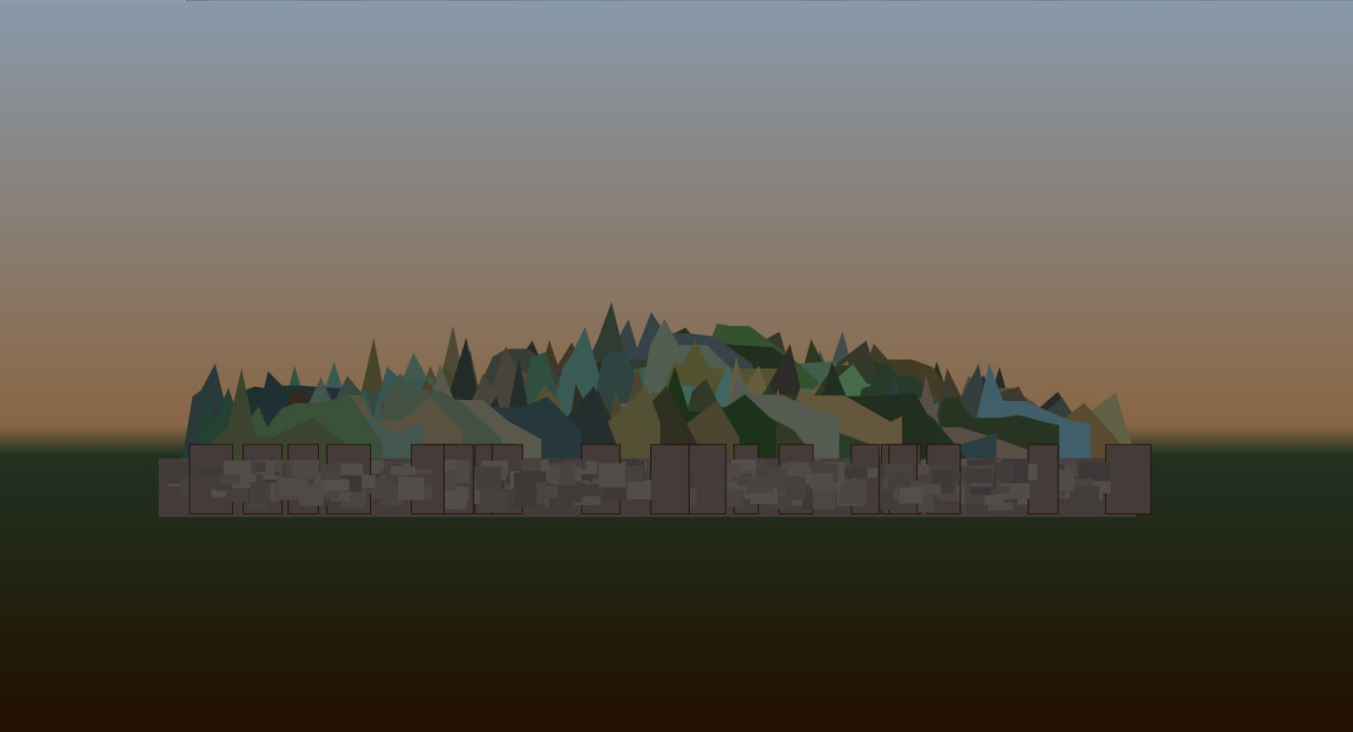
<svgr:random min="M 175,200 100,200 100,130 H 120 L 140, 90 155, 90 180, 50 205, 90 H 230 L 280, 90 360,130 360 200 z"
attributeName="d" max="M 175,200 100,200 100,190 H 120 L 140,160 155,160 180,120 205,160 H 260 L 340,170 360,190 360 200 z" />
<svgr:random attributeName="fill" min="hsl(20, 5%, 15%)" max="hsl(200, 30%, 35%)" />
Random Medieval Town with Wall – above code shows the use of HSL colors to improve chromatic control.

First, in this figure, the building contours are considerably more ambitious, consisting of 12 sided figures instead of pentagons. Secondly, the wall is given a texture by replicating rectangles with random offsets back and forth from left to right in several layers. The code may be worth examination to understand how such an effect may be accomplished.
A final version of these random cities can be seen at http://cs.sru.edu/~ddailey/svg/randA8.svg . In this example, a handful of different shapes (spires) are interleaved at random behind the foreground buildings, and clouds are added.
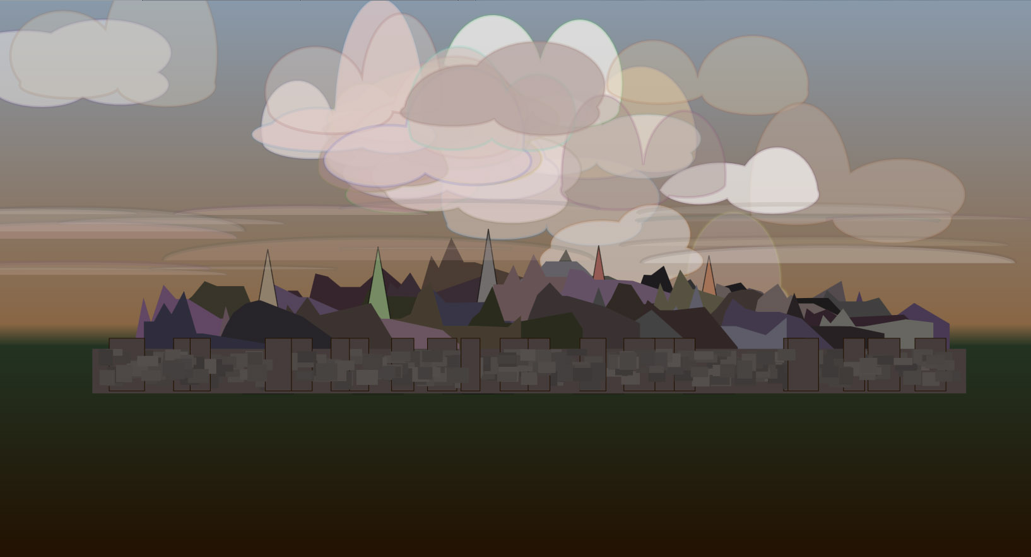
<path fill = "white" stroke-width = "8" stroke-opacity = ".15" fill-opacity = ".25" >
<svgr:random min="M 0,0 A 130 5 0 0 1 300,0 "
attributeName="d" max="M 0,0 A 300 20 0 0 1 1000,0 " />
<svgr:random attributeName="fill" min="hsl(0, 0%, 70%)" max="hsl(50, 70%, 100%)" />
<svgr:random min="translate(-1000,-70)" attributeName="transform" max="translate(1000,50)" />
<svgr:random attributeName="fill-opacity" min=".1" max=".25" />
<svgr:replicate repeatCount="15" />
</path>
Random medieval city with random wall and random clouds. Code above shows simpler stratus clouds in foreground.

The clouds in the background are a bit more complex, with arc commands shaping both the top and bottom of the clouds, but the ones in the foreground, as illustrated in the table are a bit easier to understand. We simply draw a narrow arc from left to right, with the baseline (y=0) remaining fixed but varying from 300 to 1000 in the horizontal offset. The vertical and horizontal radii, though of the arc are what determines the “personality” of the cloud. The same effect is generalized to produce even more personality for the cumulus clouds seen behind the city.
Two more illustrations of this play with random shapes are worthwhile.
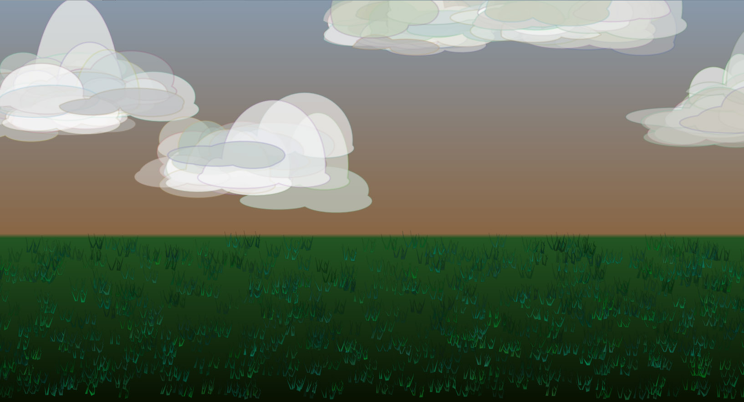
Example at http://cs.sru.edu/~ddailey/svg/randB0.svg
Clouds: normal and uniform with grass.

These clouds are drawn as before using arc subcommands of the <path> element. The difference is that a cluster of eight clouds are tightly aggregated into a group and then five of those groups are randomly positioned. The effect of “tight aggregation” is accomplished by letting the distribution of the x and y translations be normal rather than uniform, hence discouraging “deviance” or at least controlling it more tightly. The clusters of eight cloud-layers then form “superclouds” that are then replicated uniformly five times. The grass then consists of some pointy little polygons that vary as follows:
<svgr:random min="M 0,100 l -8,-22 -3,-16 2,14 L 2,100 l 0,-15 2, -8 -2,12 L 4,100 M 12,98 l -8,-20 -3,-16 2,14 L 14,100 l -2,-15 2, -8 -2,12 L 16,100 l 2,-15 -5, -8 3,12 L 17,100 l 0,-15 2, -8 -2,12 L 18,100 z"
attributeName="d" max="M 0,100 l 6,-15 -2,-14 3,16 L 3,100 l 8,-25 2, -8 -2,12 L 6,100 M 12,105 l 6,-12 -2,-14 3,16 L 15,100 l 0,-15 2, -8 -2,12 L 16,100 l 7,-15 -4, -8 5,12 L 18,100 l 8,-25 2, -8 -2,12 L 19,105 z " />

Eight hundred clumps of grass are then laid out uniformly across the rectangle of the lawn using
<svgr:random min="translate(-20,450)" attributeName="transform" max="translate(1500,790)" />
<svgr:replicate repeatCount="800" />

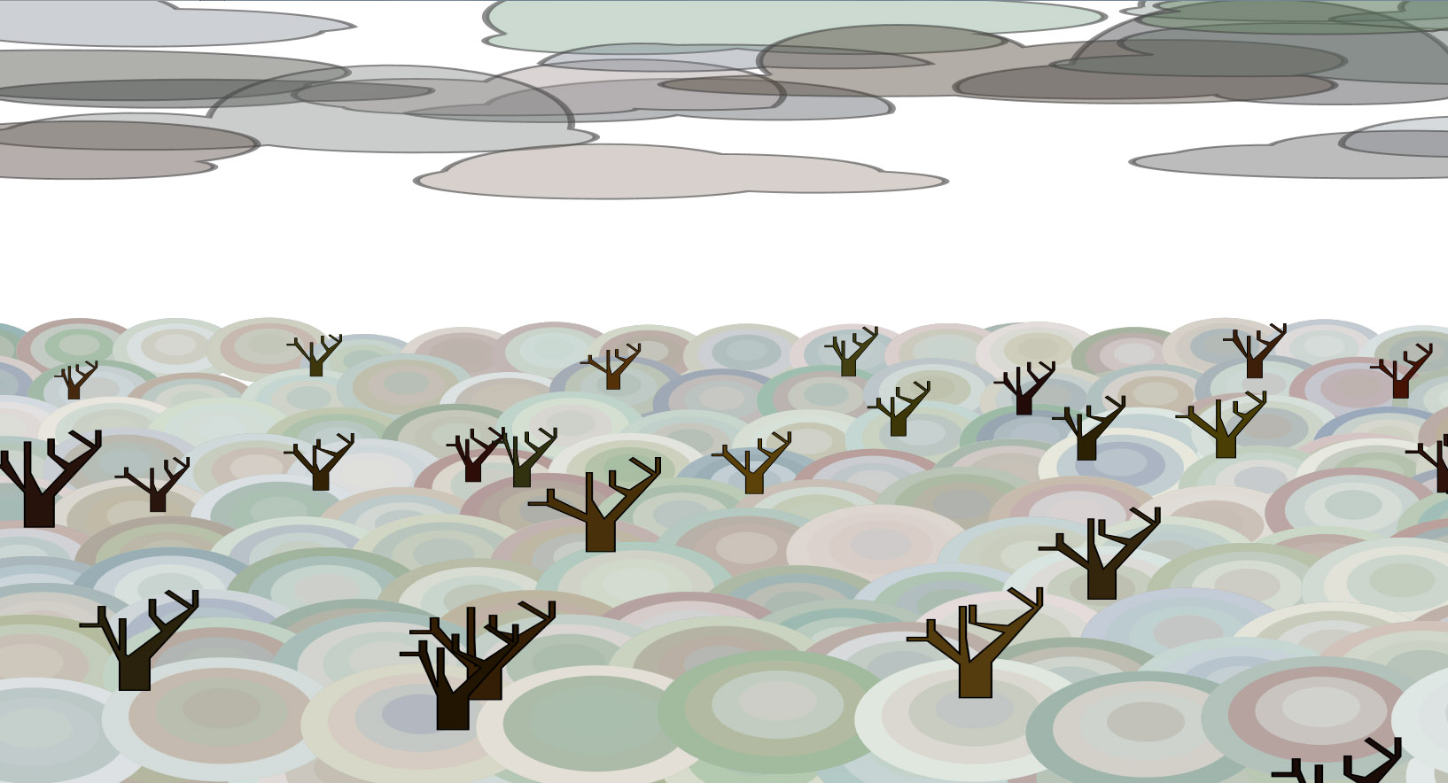
http://cs.sru.edu/~ddailey/svg/randB7.svg
Random trees over andom hillocks slightly displaced from grid points and given perspective.

This example illustrates some of the relative difficulty in controlling paths randomly. The tree template is controlled by
<svgr:random min="M 0,0 v -45 l -40,-50 h -20 v -4 h 15 v -22 h 5 v12 L 0,-50 v -70 h 5 v 30 L 5 -44 35,-74 l-30,-30 v-20 h5 v 20 L 38,-82 l 20,-20 -20,-20 3,-3 20,20 v-20 h4 v20 L 25,-40 25,0 z"
attributeName="d" max="M 0,0 v -35 l -10,-20 h -15 v -4 h 17 v -12 h 6 v12 L 0,-50 v -30 h 5 v 45 L 16 -40 35,-74 l-10,-10 v-20 h5 v 20 L 38,-82 l 20,-20 -20,-20 3,-3 20,20 v-20 h4 v20 L 25,-40 25,0 z " />

This is tedious and not very effective since, in order to have the branches not become triangular, very tight control over their begin and end points must be exerted, hence considerably limiting their shape and styles. We can control, to some extent, how far the first branch extends to the left but the point of beginning and the point of termination of a branch cannot be too far away and there is no way within the current model to yoke values together. We might either try to develop a far more sophisticated model of remembering values, whence the declarative model starts to resemble script, or we might ask of SVG that it enhance path syntax with a bit more internal complexity. Perhaps our next project will be to undertake more complex syntactic studies of path subcommands, that would work nicely in combination with <random> and <replicate>.
The hillocks are simply clusters of concentric ovals laid out with slight displacement from their natural grid points. What is perhaps instructive about this example is the way that both scale and translation are employed to give the illusion of perspective. Trees and hillocks in the foreground are larger than those behind.
We will return to our study of shapes again after visiting the issues of layout and animation a bit.
Layout
In the above examples, the quasi-random distribution of items across the plane has been demonstrated. Let us now illustrate some of the capabilities that replicate and randomness bring.
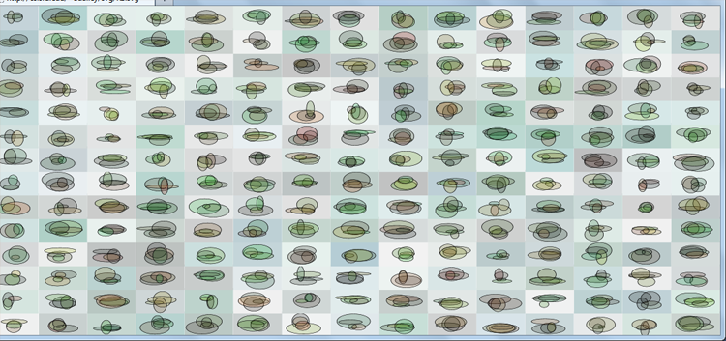
http://cs.sru.edu/~ddailey/svg/R1.svg
<g>
<g transform="translate(0,900)">
<rect fill="#bbb" x="0" y="0" height="70" width="98">
<svgr:random attributeName="fill" min="hsl(150,0%, 75%)" max="hsl(200, 30%, 95%)" />
</rect>
<ellipse […] />
<svgr:replicate repeatCount="15" >
<svgr:replicateAttribute attributeName="transform" values="translate(0,900);translate(0,-68)" />
</svgr:replicate>
</g><svgr:replicate repeatCount="15" >
<svgr:replicateAttribute attributeName="transform" values="translate(1480,0);translate(0,0)" />
</svgr:replicate>
</g>
Random content replicated uniformly in x,y
In the above example, an ellipse is designed with several random attributes:
<ellipse cx="44" cy="16" rx="20" ry="12" fill="#358" fill-opacity=".20" stroke="black" stroke-width="1">
<svgr:random attributeName="fill" min="hsl(0, 60%, 0%)" max="hsl(150, 100%, 40%)" />
<svgr:random attributeName="rx" min="7" max="35" />
<svgr:random attributeName="ry" min="4" max="22" />
<svgr:random attributeName="cx" min="35" max="58" />
<svgr:random attributeName="cy" min="26" max="48" />
<svgr:replicate repeatCount="1" />
</ellipse>

The ellipse is replicated once. The fact that four ellipses occur in each of its instances across the other replications is a bug in our software that we are looking into. We rather like the result, but it would be nice to be able to get exactly what we asked for!
Next, the ellipse is replicated first vertically:
<svgr:replicateAttribute attributeName="transform" values="translate(0,900);translate(0,-68)" />
then horizontally:
<svgr:replicate repeatCount="15" >
<svgr:replicateAttribute attributeName="transform" values="translate(1480,0);translate(0,0)" />
The interpolation performed assumes that the string components match, and then simply creates interpolated values across the numeric portions of the transforms. Fortunately, it works for compound transforms as well.
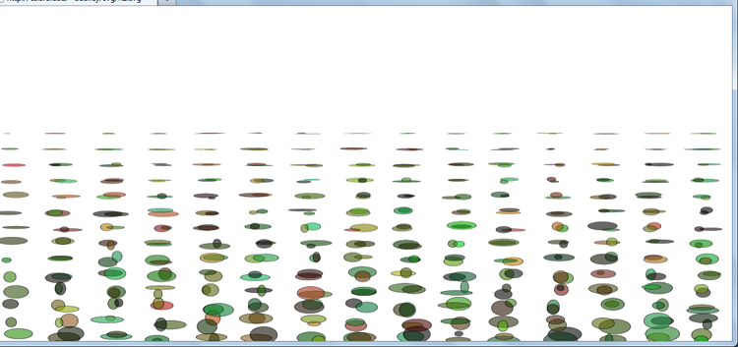
http://cs.sru.edu/~ddailey/svg/R2.svg
[…]
<svgr:replicate repeatCount="15" >
<svgr:replicateAttribute attributeName="transform" values="translate(0,900) scale(1,1);translate(0,300) scale(.8,0)" />
</svgr:replicate>
</g>
Correlating vertical scale with vertical position.

In this example, we can see that we may concurrently modify both translation and scale, resulting in the appearance that things get smaller as they recede into the background. Unfortunately, even though we modified the horizontal scaling a bit to try to conform to the illusion, the centroids of the content remain constant across the y axis, leaving increasingly large gaps between the columns. This is largely overcome in the next example by also adding skewX to the collection of transforms performed.
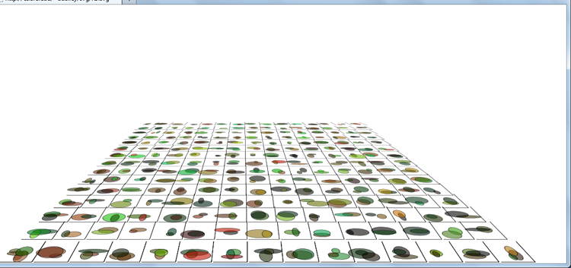
http://cs.sru.edu/~ddailey/svg/R3.svg
[…]
<svgr:replicate repeatCount="15" >
<svgr:replicateAttribute attributeName="transform" values="translate(-450, 0) skewX(-20);translate(750,0) skewX(30)" />
</svgr:replicate>
</g>

<svgr:replicate repeatCount="15" >
<svgr:replicateAttribute attributeName="transform" values="translate(520, 840) scale(1.1,.8);translate(595,400) scale(.45,.1)" keySplines="0,0 .2,.7 1,1"/>
</svgr:replicate>
</g>
Perspective effect
In this case, we have varied the horizontal skew of the tiles (to which has been added a small backwards-L path to help frame the rectangle and display the precision (or lack of it) of our effect. It should be noted that a few(maybe four) minutes of play with the values of skew, translate, and scale were necessary to optimize the effect and that, even after this play, there remains some imprecision. Another example at http://cs.sru.edu/~ddailey/svg/randomD3.svg is much crisper, perhaps owing to a few more minutes of adjustment.
You will note that the vertical replication involves the keySplines attribute. It is quite important to allow unequal spacing between the rows. If it is removed from the code, you may verify that the rows remain equidistant from one another, quite spoiling the perspective effect.
One more important technique for controlling the pseudo-random layout of content should be discussed: replicatePath, as illustrated below.
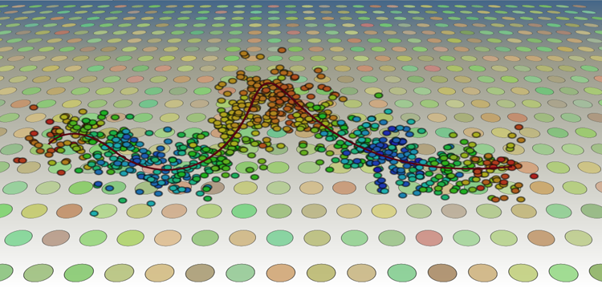
http://cs.sru.edu/~ddailey/svg/R4.svg
<ellipse cy="-200" ry="8" rx="9" stroke-opacity=".5" stroke-width="4" stroke="black" >
<svgr:random attributeName="transform" min="translate(-240,-300)" max="translate(240,300)" distribution="normal"/>
<svgr:replicate repeatCount="800">

<svgr:replicatePath xlink:href="#curve" xattribute="cx" yattribute="cy" />
<svgr:replicateAttribute attributeName="fill"
values="hsl(0, 70%, 40%);hsl(220, 70%, 40%);hsl(60, 70%, 40%);hsl(20, 70%, 40%);hsl(240, 70%, 40%);hsl(0, 70%, 40%)" />
</svgr:replicate>
</ellipse>

<path id = "curve" fill="none" stroke = "#501" stroke-width = "5"
d = " M 140 450 S 190,364 290,470 540,552 610,320 700,590 1210,520 " />
Random normal departures from a curve

In this example, 800 small ellipses are scattered along a curve. This is done using <replicatePath>, a more powerful analog of the animateMotion element of early SVG (since it allows any pair of attributes to have their values defined by a given curve). <replicatePath> is documented in the <replicate> proposal [20]. Instead of simply laying the content out along the path, though, as in the example at http://cs.sru.edu/~ddailey/svg/randomA3.svg, each ellipse has its own random transform (in both the x and y directions) applied. The background utilizes the perspective effect discussed in the previous example.
Animation
Adding animation to replication is an exciting prospect as those who have examined some of our animated examples can testify. Not only can one create 3D objects using <replicate> but one can rotate them about both y and z axes by animating gradients and animating transforms. See the examples at http://srufaculty.sru.edu/david.dailey/svg/SVGOpen2010/demo9.svg and
Where randomness comes in is that
- the shapes that are animated can be more interesting and natural 3D shapes as in http://cs.sru.edu/~ddailey/svg/randC5.svg
- The paths that things follow can be randomly constructed as in http://cs.sru.edu/~ddailey/svg/randC0.svg
and
- The animation frequencies may be randomized as in http://cs.sru.edu/~ddailey/svg/randE3.svg
The gallery, located at http://cs.sru.edu/~ddailey/svg/replicateRandom.html shows many examples, but the two at http://cs.sru.edu/~ddailey/svg/randF0.svg and http://cs.sru.edu/~ddailey/svg/randF2.svg form an interesting contrast between desynchronized behavior that is uniformly distributed versus that which is normally distributed.
ReplicateModifiers and Seeds
[Hoping Eric can do this. Examples can be found at
http://cs.sru.edu/~ddailey/svg/randC7.svg
http://cs.sru.edu/~ddailey/svg/randD4.svg (currently Opera only: needs to be reworked for Firefox)
http://cs.sru.edu/~ddailey/svg/randomD12.svg (Opera, Safari, IE )
http://cs.sru.edu/~ddailey/svg/randomE0.svg
http://cs.sru.edu/~ddailey/svg/randomE2.svg (Opera only)
http://cs.sru.edu/~ddailey/svg/seeds.svg

[1]Tim Berners-Lee http://bits.blogs.nytimes.com/2009/10/12/the-webs-inventor-regrets-one-small-thing/
[2] http://cs.sru.edu/~ddailey/svg/2011/OmniTalk.html
[3] Leon Battista Alberti on Painting, 1436, as translated by John R. Spencer, 1966, Yale University Press.
[4] , Erwin Panofsky Idea: A Concept in Art Theory, 1924, translated by Joseph J.S. Peake, 1968, Harper & Row Publishers.
[5] Rensselaer Lee. Ut Pictura Poesis: The Humanistic Theory of Painting, , 1967, W.W. Norton & Co.
[6] H.W. Janson. History of Art (3rd Edition), 1986, Henry N. Abrams, Inc. New York.
[7] , Meredith Malone. Chance Aesthetics 2009 Mildred Lane Kemper Art Museum, Washington University in St. Louis. http://www.press.uchicago.edu/Misc/Chicago/9780936316277_blad.pdf

[8] Ethan Ham. Chapter V: Randomness, Chance, & Art, in Handbook of Research on Computational Arts and Creative Informatics by Braman, James, Giovanni Vincenti and Goran Trajkovski.IGI Global, 2009. 1-500. Web. 30 Aug. 2012. doi:10.4018/978-1-60566-352-4 http://www.irma-international.org/viewtitle/19713/

[9] Metropolis, N.; Ulam, S. (1949). "The Monte Carlo Method". Journal of the American Statistical Association (American Statistical Association) 44 (247): 335–341 http://home.gwu.edu/~stroud/classics/MetropolisUlam49.pdf

[10] Eckhardt, Roger (1987). "Stan Ulam, John von Neumann, and the Monte Carlo method". Los Alamos Science, Special Issue (15): 131–137.
[11] Stanislaw Ulam. “On some mathematical properties connected with
patterns of growth of figures.” Proceedings of Symposia on Applied
Mathematics 14, 215–224. 1962. Also, technical paper, LASL, personal communication, 1976
[12] Benoit Mandelbrot. The Fractal Geometry of Nature,. Henry Holt & Co., 09/01/1982
[13] Fractals, Wikipedia, 2012.
[14] Richard Taylor, Adam P. Micolich and David Jonas Fractal Expressionism: Can Science Be Used To Further Our Understanding Of Art? http://phys.unsw.edu.au/phys_about/PHYSICS!/FRACTAL_EXPRESSIONISM/fractal_taylor.html
[15] “Constructing Random Polygons.” David Dailey and Deborah Whitfield. Proceedings of the 9th ACM SIGITE conference on Information technology education. Copyright 2008 Association for Computing Machinery.
[16] Simplex noise http://en.wikipedia.org/wiki/Simplex_noise
[17] David Dailey, Jon Frost, Domenico Strazzullo. Building Web Applications with SVG. Published with the authorization of Microsoft Corporation by O’Reilly Media, Inc., 2012
[18] Hardy, Vincent, et al. Filter Effects 1.0 Editor's Draft 21 August 2012. https://dvcs.w3.org/hg/FXTF/raw-file/tip/filters/index.html .

[19] Dailey, David. Another something to think about -- the <replicate> tag -- SMIL for space instead of time. W3C SVG Interest Group. 2008. http://lists.w3.org/Archives/Public/public-svg-ig/2008JulSep/0109.html

[20] Dailey, David and Elder, Eric. A proposal for adding declarative drawing to SVG. 8th Annual Conference, SVGOpen. W3C and SVG Working Group. Paris, Fall 2010 http://svgopen.org/2010/papers/46-A_proposal_for_adding_declarative_drawing_to_SVG/index.html

[21] David Dailey, 2011. http://lists.w3.org/Archives/Public/www-svg/2011May/0022.html
[22] David Dailey, 2011. http://lists.w3.org/Archives/Public/www-svg/2011Nov/0016.html
[23] David Dailey, 2011. http://tech.groups.yahoo.com/group/svg-developers/message/65364
[24] SVG Working Group 2011. http://www.w3.org/Graphics/SVG/WG/wiki/SVG2_Requirements_Input#Randomization
[25] Charles Pritchard, 2011. http://lists.w3.org/Archives/Public/www-svg/2011Nov/0017.html
[26] Phillipe Hayer, 2011. http://tech.groups.yahoo.com/group/svg-developers/message/65366
[27]Richard Pearman, 2011. http://tech.groups.yahoo.com/group/svg-developers/message/65367
[28]Charles Pritchard, 2011. http://lists.w3.org/Archives/Public/www-svg/2011Nov/0030.html
[29]Robert O. Callahan, 2011. http://lists.w3.org/Archives/Public/www-svg/2011Nov/0027.html
[30] Ben Kay, 2011. http://lists.w3.org/Archives/Public/www-svg/2011Nov/0042.html
[31] Olaf Hoffmann, 2011 http://tech.groups.yahoo.com/group/svg-developers/message/65367
[32] reference on random number method
[33] Box-Muller transform at Wikipedia, 2012. http://en.wikipedia.org/wiki/Box%E2%80%93Muller_transform
[34]David Dailey, Adding a <replicate> tag to SVG. 2010-2012 http://srufaculty.sru.edu/david.dailey/svg/SVGOpen2010/replicate.htm
[35] David Dailey and Deborah Whitfield: Geometric Accessibility: Who needs SVG? http://cs.sru.edu/~ddailey/svg/GeometricAccessibility.html
----------other references that could prove useful------
http://www.rednoise.org/res/Ham_StochasticArt.pdf
Understanding Uncertainty: Pure Randomness in Art: http://understandinguncertainty.org/node/1066 David Spiegelhalter
John Cage, Ellsworth Kelly, Kenneth Martin: chance and order

Kenneth Martin’s work at http://www.planetaryfolklore.com/2011/04/chance-and-order.html
http://en.wikipedia.org/wiki/Cut-up_technique

