- (5 points) Given heap below, draw the heap after inserting 105 and 41
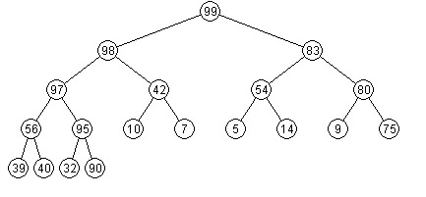

- (5 points) Given heap below, show the heap after deleting 99 followed by 98

